

Lab Report
Submitted to:
Niaz Ashraf Khan
Submitted By:
Name: Sumaia Afroz Sayka
ID:223014034
Program: cse1202

Sec: 02
Date of Submission : 26th April 2023
Online student management system
An online student management system helps the students to know about their all kinds of information like their id , courses, number of courses what they need to take and how to take them etc. And it also helps the users to know about the informations about the students and so on.
Description of the project:
This code first include a header file which provides the functions with input and output. This code declares a structure which includes courseinfo which has two fields such as coursecode and courseno, by which the user will get to know about the above informations about the course.
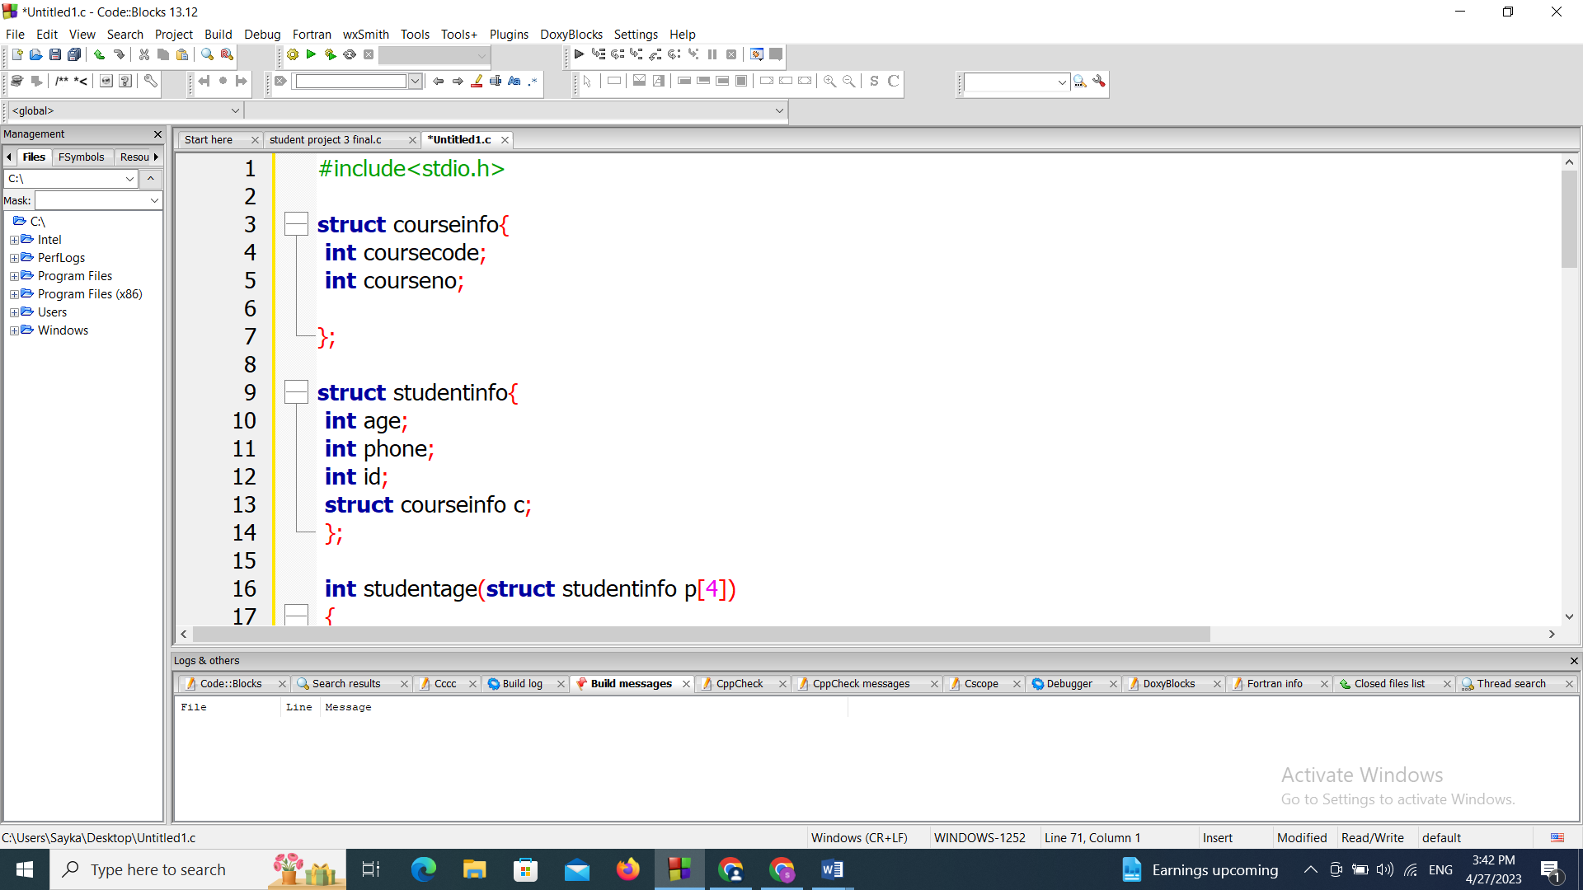
This code also declares a structures which includes studentinfo which includes three fields like age, phone , id and also calls the previous structure which is courseinfo declaring a variable c.
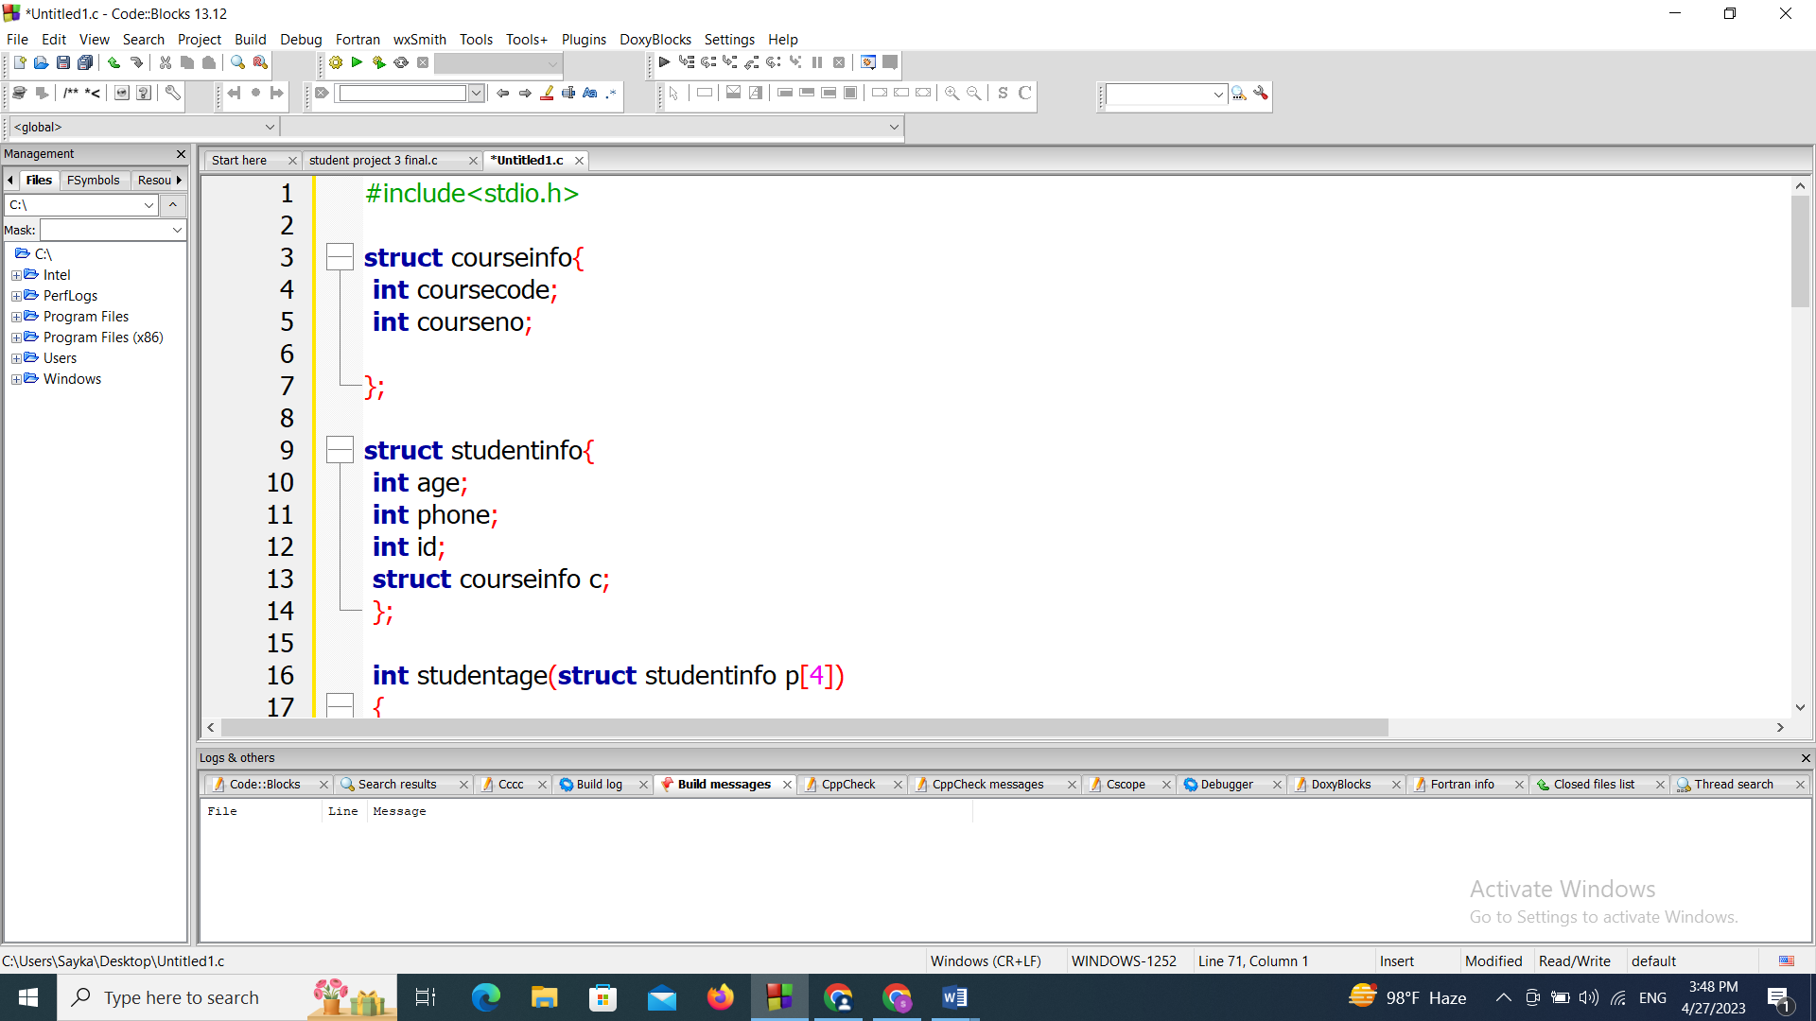

This code declares the main function in which includes the structure variable as person[4], which is an array of structure and we declared i as an integer variable and used a for loop to take the input from the user and then the main function called the three function named studentid(person), studentage(person) ,studentphonenumber(person) .

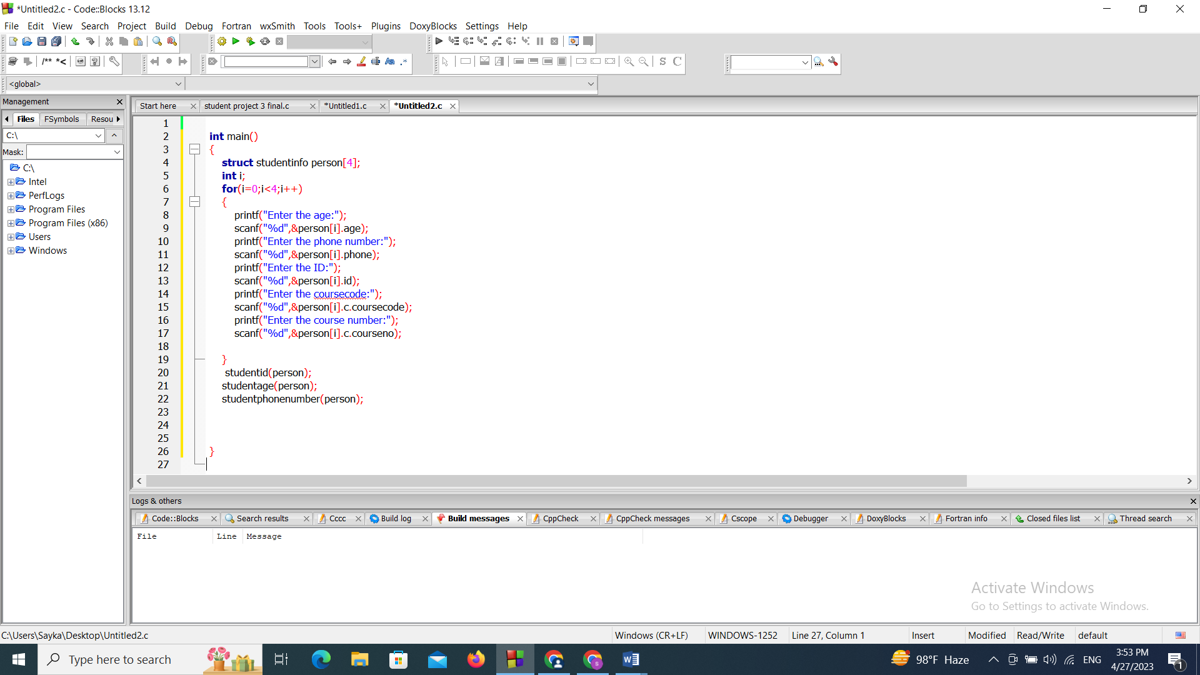
This code declares a function called studentage which takes the value of structure variable declaring another variable p[4], then we used a for loop to continue to print the age in which we used a while loop which says if p[i].age==30 then the age will be printed.

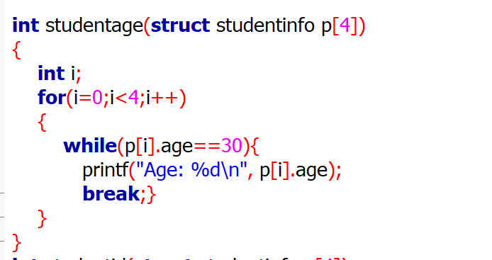
This code declares another function which is called studentid which declares a structure variable by using a variable q[4].Then we used a for loop to continue printing the value and here we used an if logic which includes that if q[i].id==223 then it will print the id of the student.

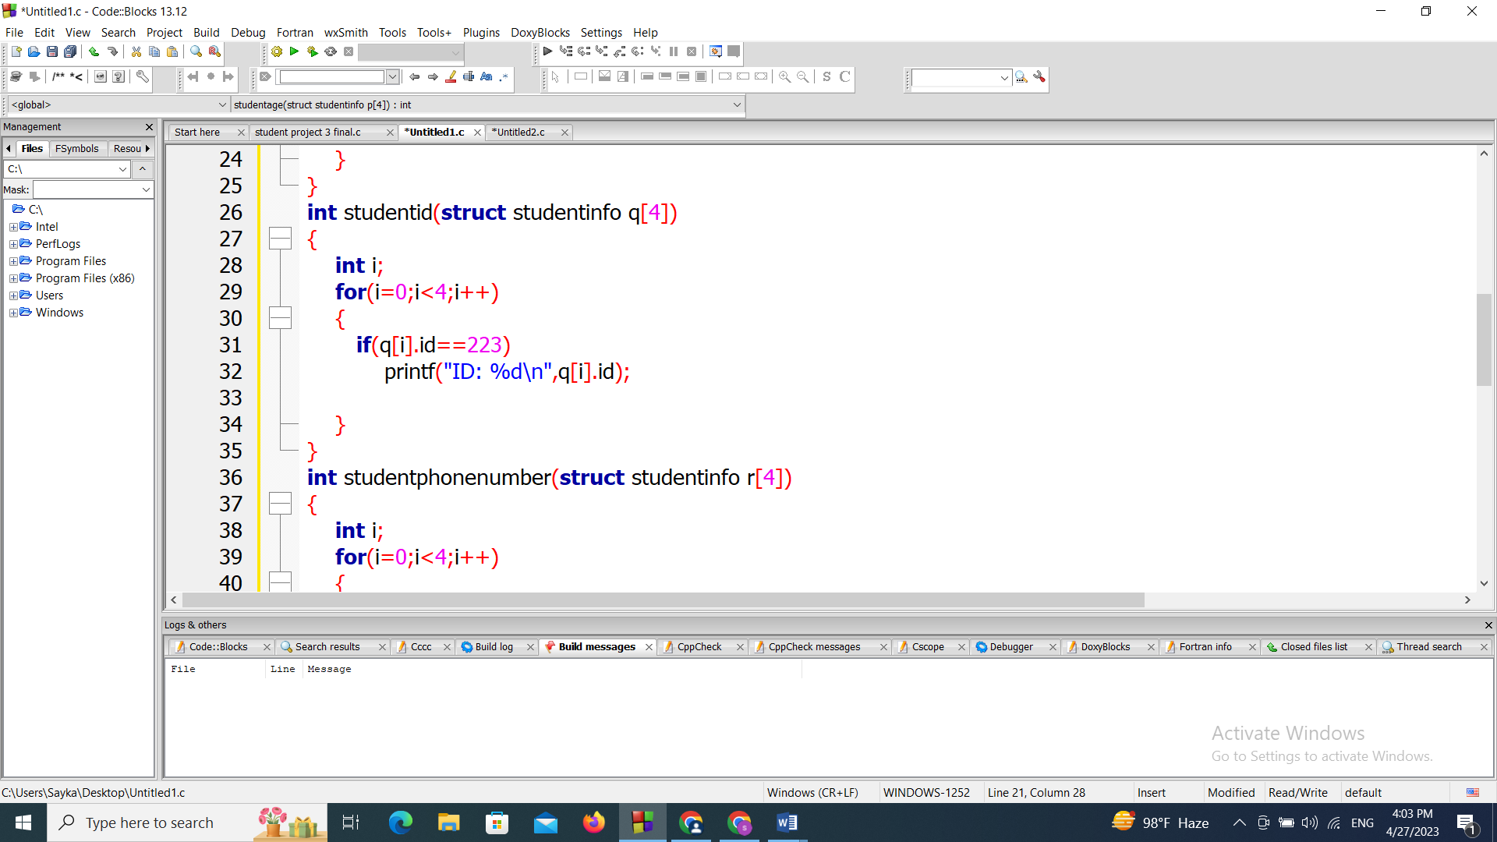
This function is called studentphonenumber which also declares a structure variable using another variable as r[4]. Then we used a for loop to continue printing and here we used an if logic which says if r[i].phone is less than 1000 && r[i].phone greater than 0 then it will print the phonenumber of the student.

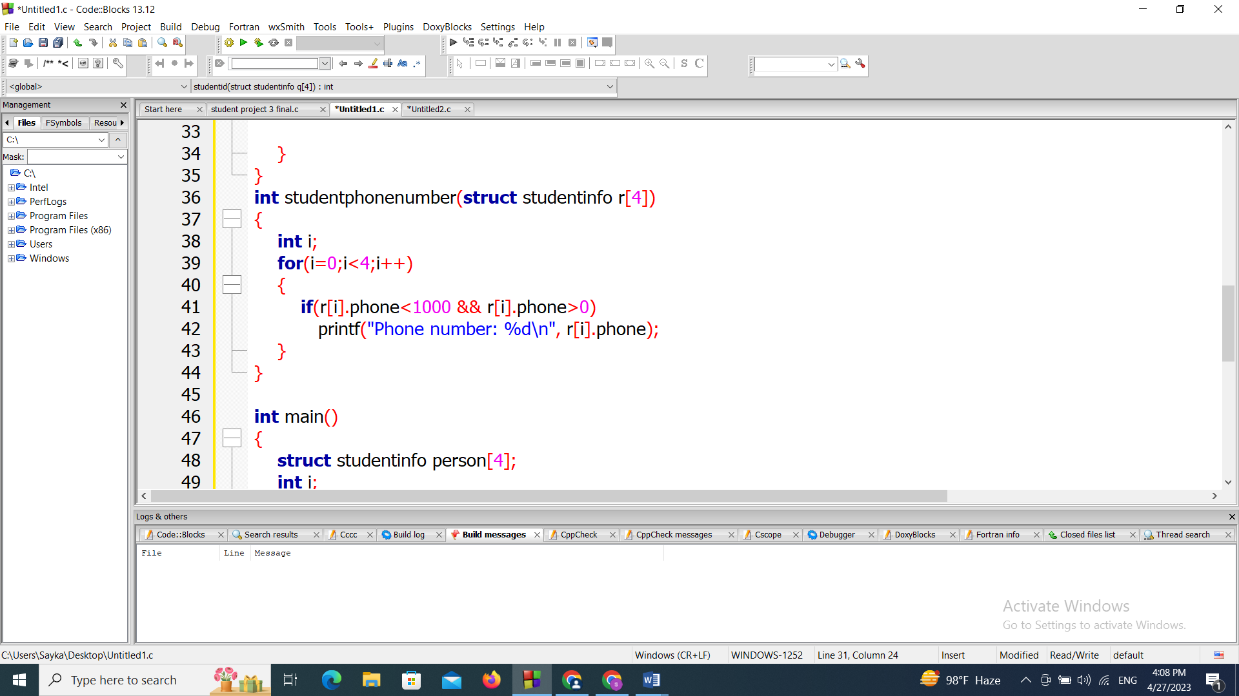

Function 1:
Screenshot of the code:
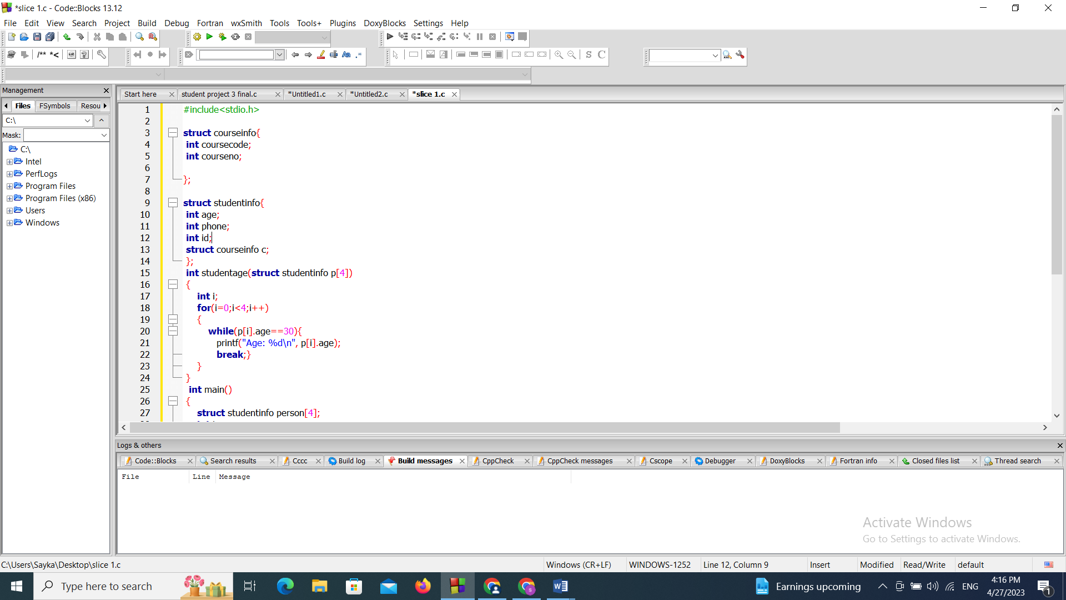
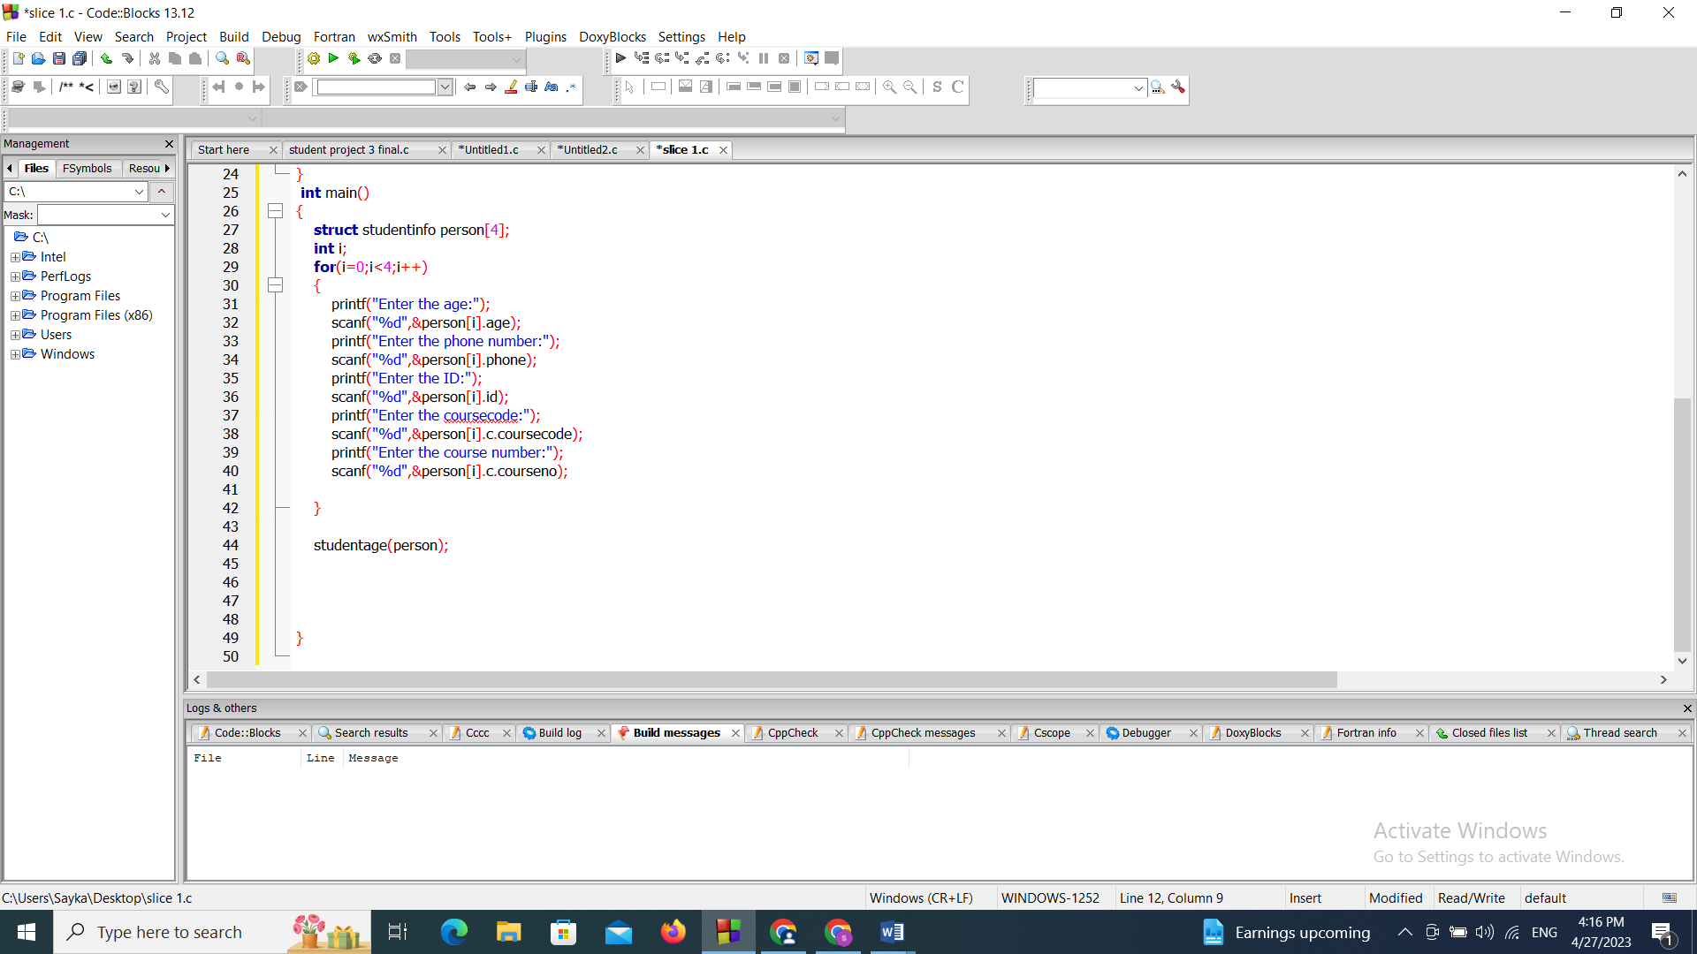

Screenshot of the console:
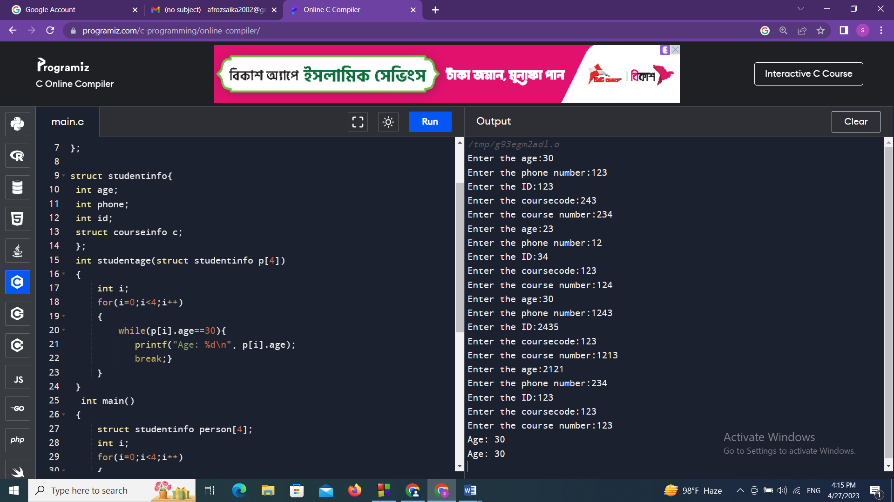

Description:
This code declares a function called studentage which takes the value of structure variable declaring another variable p[4], then we used a for loop to continue to print the age in which we used a while loop which says if p[i].age==30 then the age will be printed.

Function 2:
Screenshot of the code:
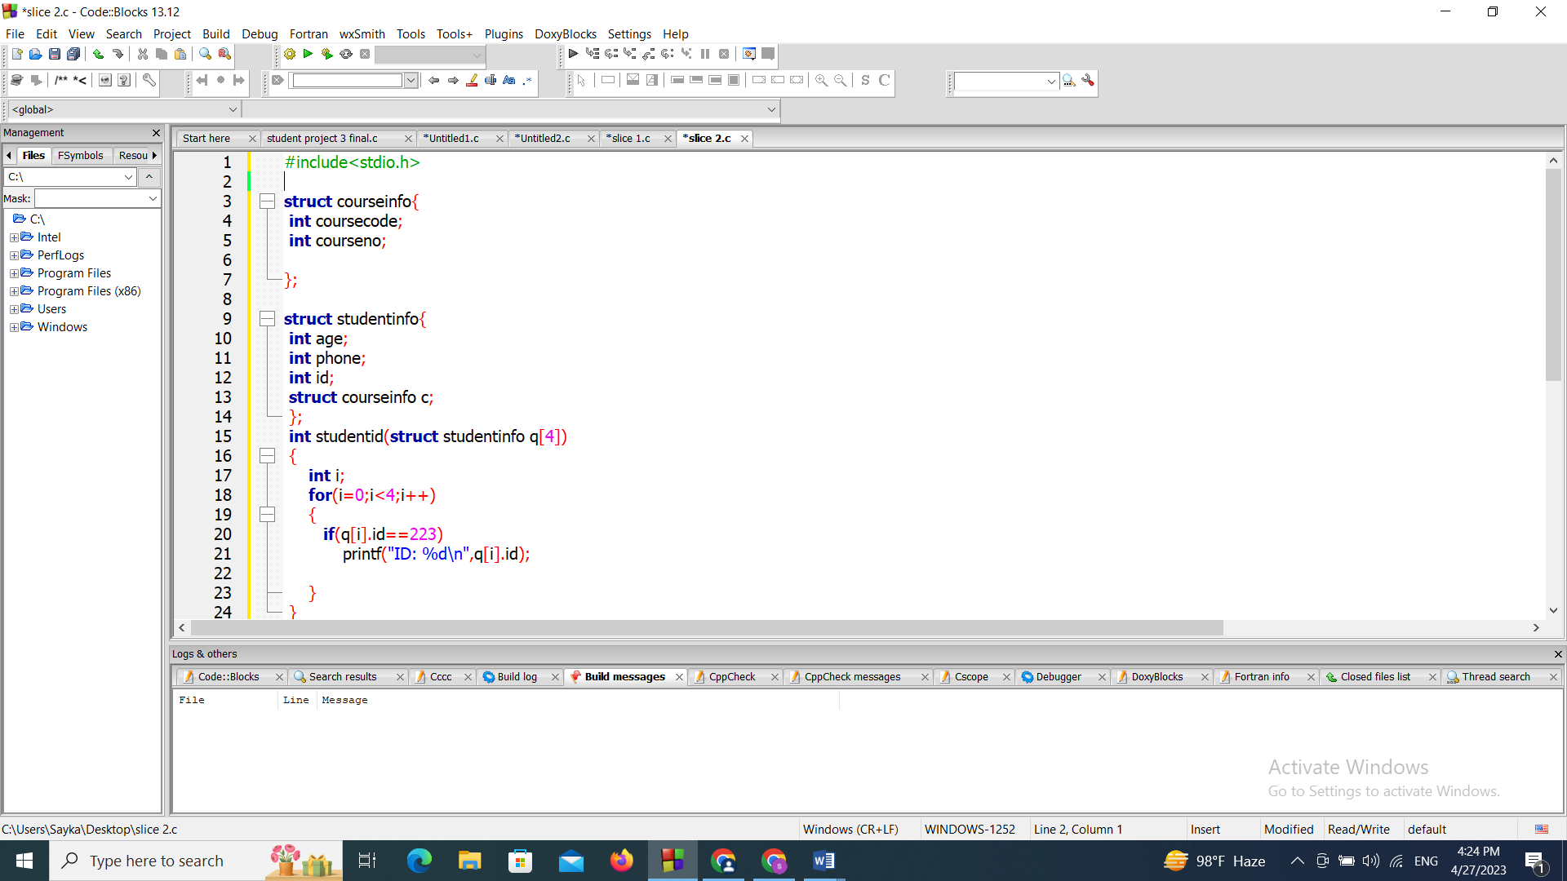
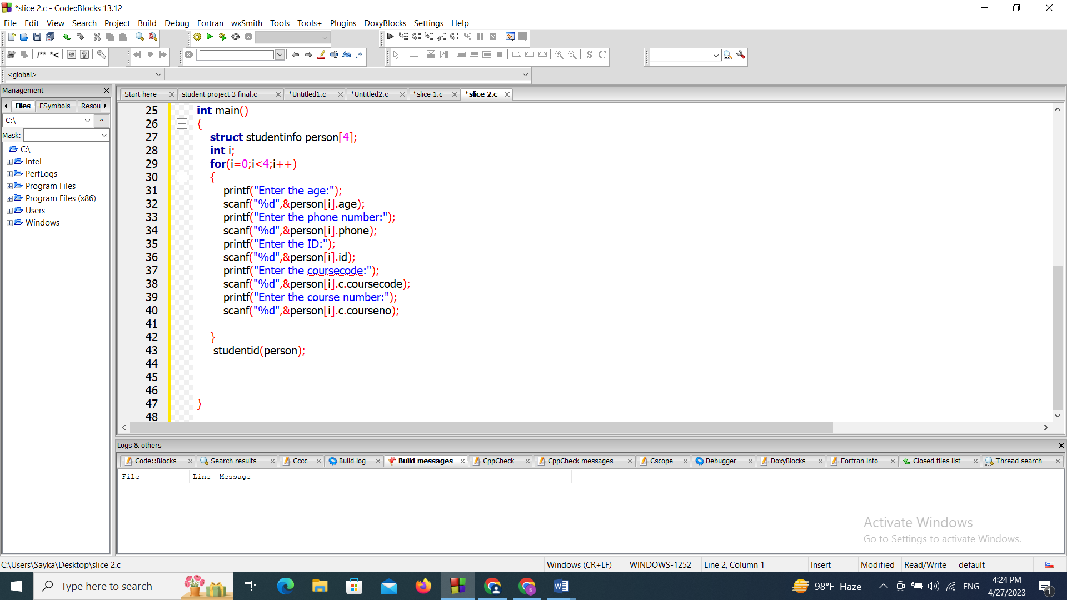
Screenshot of the console:
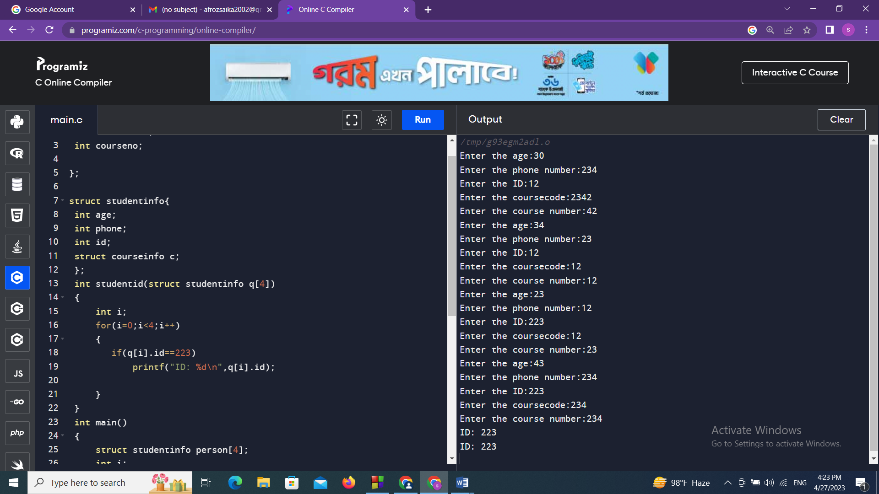

Description:
This code declares another function which is called studentid which declares a structure variable by using a variable q[4].Then we used a for loop to continue printing the value and here we used an if logic which includes that if q[i].id==223 then it will print the id of the student.

Function 3:
Screenshot of the code:
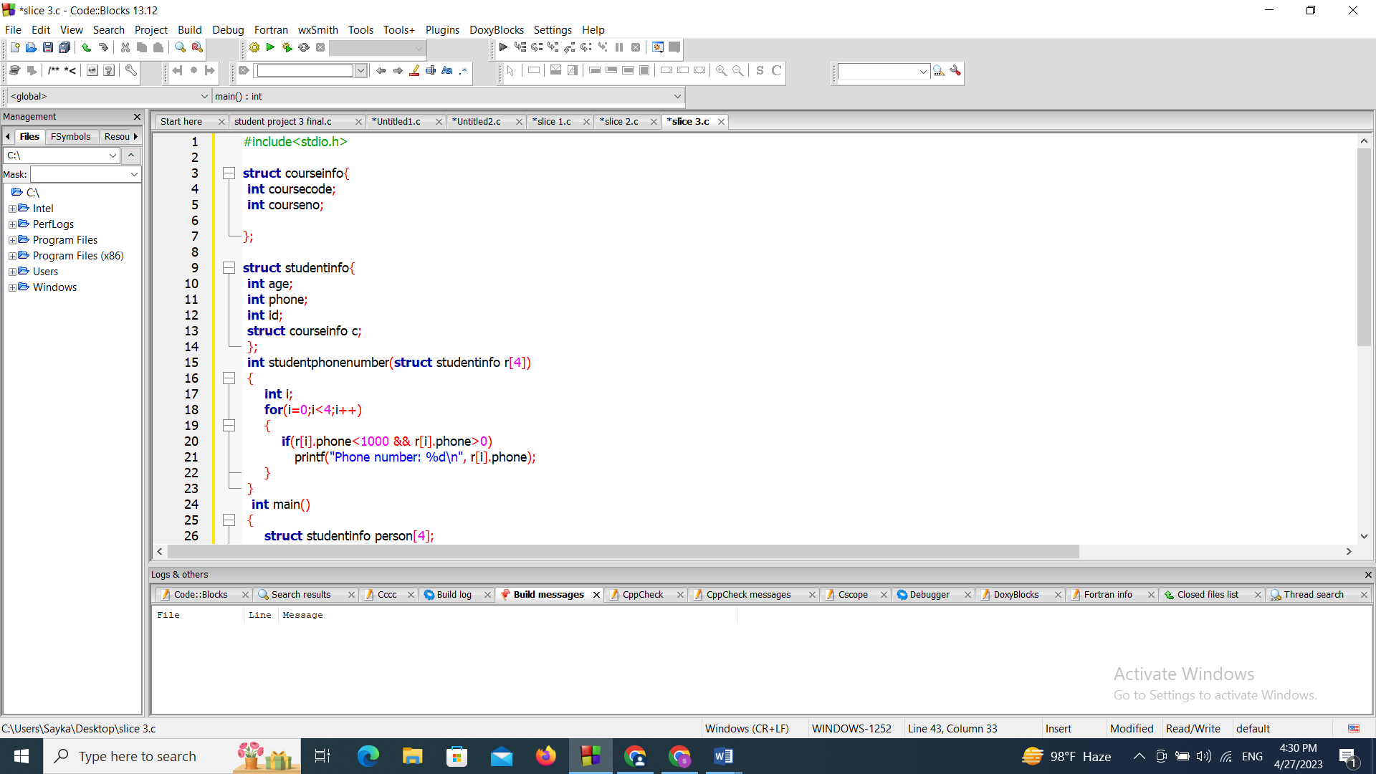
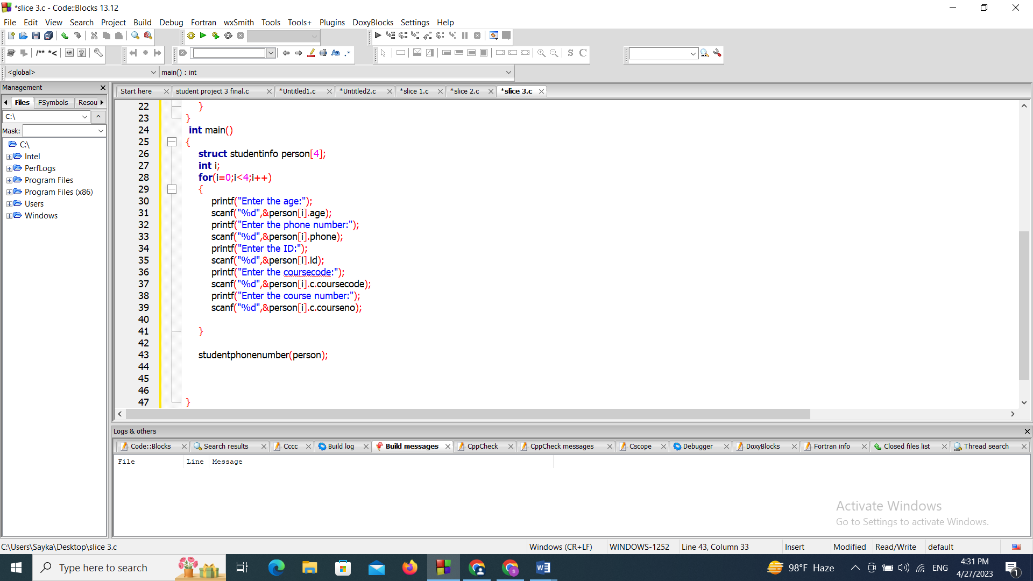
Screenshot of the console:
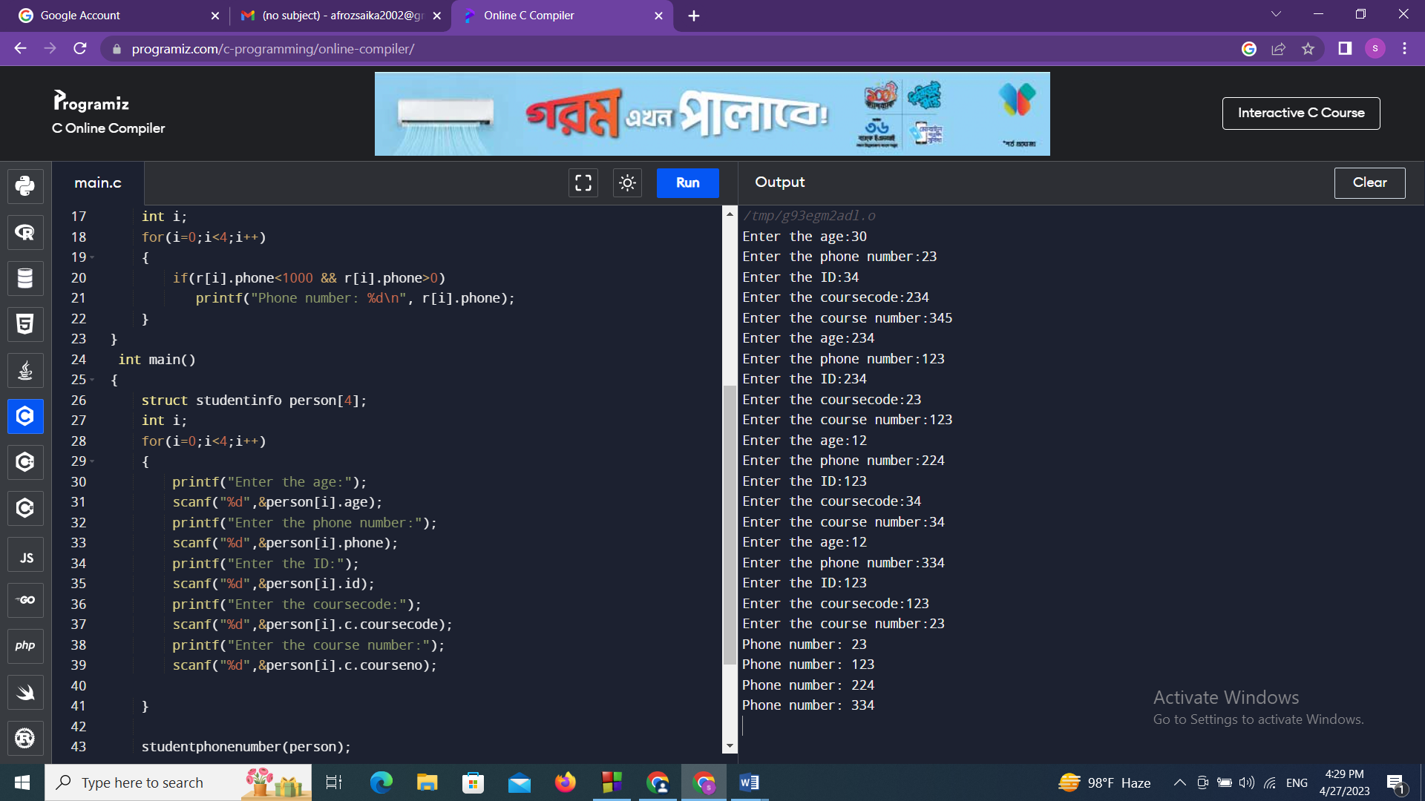

Description:
This function is called studentphonenumber which also declares a structure variable using another variable as r[4]. Then we used a for loop to continue printing and here we used an if logic which says if r[i].phone is less than 1000 && r[i].phone greater than 0 then it will print the phonenumber of the student.
Conclusion:
An online student management system is very useful for a user to find any information about a student and to know about him. It has also made the students’ life easy including their study so that they can easily find their information in a minute.

